Guidelines for plant phenological observations

Elisabeth Koch¹, Ekko Bruns², Frank M. Chmielewski³, Claudio Defila⁴, Wolfgang Lipa¹,
Annette Menzel⁴

¹ Zentralanstalt für Meteorologie und Geodynamik, Austria
² Deutscher Wetterdienst, Germany
³ HU Berlin, Germany
⁴ MeteoSwiss, Switzerland
⁵ TU München, Germany

Table of contents

1. Introduction 2
Definition of phenology and seasonality 2
Benefits of phenological observations for NMHS 2
Importance of phenology for Climate Change studies 3
Short history of phenology 4
Applications of phenological observations 5
2. Guide to observations 5
Principles for observations 5
Which plants 6
Which phases 6
Where 7
When, how often 8
3. Data Documentation – Metadata 8
4. Data management 8
5. Going public – publications, services and products 9
6. References 9

1. Introduction

Definition of phenology and seasonality
“Phainestai” the ancient Greek word meaning ‘to show or to appear’ is found in many modern language words reflecting the original.
Modern phenology is the study of the timing of recurring biological events in the animal and plant world, the causes of their timing with regard to biotic and abiotic forces, and the interrelation among phases of the same or different species (Lieth, 1974). Leaf unfolding, flowering of plants in spring, fruit ripening, color changing and leaf fall in autumn as well as the appearance and departure of migrating birds and the timing of animal breeding are all examples of phenological events.

ATMOSPHERE  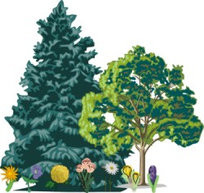  INDIVIDUAL CHARACTERISTICS  BIOSPHERE  SOIL | The plant and its environment (Defila, 1992)

Plant development, and thus phenological phases, show great interannual variability and also large spatial differences. Individual (e.g. genes, age) and environmental factors (weather and climate conditions in the micro and macro-scale, soil-conditions, water supply, diseases, competition, etc.) influence plants. They can be viewed as integrative measurement devices for the environment. The seasonal cycle of plants however is influenced to the greatest extent by temperature, photoperiod and precipitation (Sarvas 1972, 1974, Morellato and Haddad, 2000, Keatley, 2000). In particular, spring development in the Northern Hemisphere mid latitudes mainly depends on the temperature in winter and spring; in the tropics and subtropics rainfall regime is predominant.
Similarly, the timing of migration and breeding of animals is often driven, or modulated, by temperature and precipitation patterns (Dunn and Winkler, 1999, Ahas, 1999, Sparks et al, 1999, Scheifinger et al, 2005)
Seasonality here refers to non-biological events such as lake and sea icing (e.g. the “ice on or off” of the Baltic Sea – from Finnish records) and regular inundations of rivers (e.g. the annual flooding of the Nile was an important phenomenon in ancient Egypt enriching the soil and thus bringing good harvest).

Benefits of phenological observations for NMHS
The close relationship between plant development, weather and climate has resulted in phenological observation networks being run by the national meteorological services in many countries. Phenology is easy to observe and is a cost efficient instrument for the early detection of changes in the biosphere and therefore nicely complements the instrumental measurements of national meteorological services. Different types of phenological networks exist: phenological networks observing wild plants, agricultural observation systems and measurements of the pollen concentration by means of pollen traps. The Austrian, Estonian and Slovak NMHS e.g. and the UK Phenology Network also include observations of the timing of migration of animal species and the timing of breeding.
Up-to-date observations flow into several products generated at the NMHSs, an example are the crop disease forecasts of DWD. The start of the pollen season doesn’t only affect sensitive people but also the pollen forecasters at many meteorological services. Bulletins reporting the current pollen concentration as well as pollen forecasts are a highly esteemed product for people with allergies. Furthermore the pollen products enable important business connections in the medical sector.
From the beginning, phenological observations have been used to support the scheduling of agricultural works. Agricultural phenology networks mainly include intensive observations of fruit trees and vines. Plants vary in their sensitivity to frost or pests depending on their state of development. Information on the actual state of the cultures is indispensable to provide important support in the form of frost warnings and recommendations for pest control measures. Pest forecast models based on meteorological and phenological data have been developed in several countries to enhance cost efficiency in agriculture (e.g. agro-meteorological forecasts of the Deutscher Wetterdienst, http://www.dwd.de).
In recent years phenology has changed its image from traditional data collection to a very important integrative parameter to assess the impact of climate change on ecosystems. In this context the long data series originating from the plant and animal observation networks have become very valuable and the maintenance of the observation networks has become a higher priority within the associated national meteorological services.
Long phenological records are the basis of several climate change research projects at some national meteorological services. Due to the increased scientific value of phenology, these projects provide the opportunity for the NMHSs to gain access to third-party funding.
Phenology is a good instrument to communicate general climate characteristics as well as the effects of climate change to the broad public There is substantial public interest in phenological bulletins (e.g. in the Netherlands, Vliet et al, 2003) indicating the actual state of vegetation development during the vegetation period. The information on the characteristic of the current year (especially early or late year), may increase the public awareness of nature and its seasonal chronology and may act as a motivation for people to actively observe natural processes.
Furthermore phenology already is (and might become) an even more important topic to enhance the public relation activities of the meteorological services. Several newspaper articles throughout the year indicate the relevance of this topic for the media and public interest.

Importance of phenology for Climate Change studies
Numerous examples – from the duration of the growing season for gingko trees in Japan to the flowering of lilac in the US or the flowering of snowbells in Germany – show that climate change is significantly changing the seasonality of our eco-systems, especially in the middle and higher northern latitudes. The IPCC (Intergovernmental Panel on Climate Change) concluded in its Third Assessment Report in 2001 that many physical and biological systems, such as hydrology, glaciers and ice, vegetation, insects, birds and mammals, are already reacting to changing temperatures. By far the majority of these reactions are proceeding in the expected direction, i.e. they reflect the known relationship with temperature.
The importance of phenology lies in it’s effectiveness as a tool to monitor impacts of climate change on plants and animals. Some imminent effects on vegetation include: (1) range shifts towards the polar regions and higher altitudes; (2) changes in population density and composition of species; (3) longer growing seasons; and (4) earlier plant flowering, earlier breeding times, egg laying in the year. The last two may be best delineated by phenology. The intervals at which such events occur are very closely related to climate and weather conditions, especially temperature in spring and summer. Unlike the change in range shifts or changing composition of eco-systems, which maybe confounded by other drivers, such as land use change or habitat fragmentation, temperature is the factor of crucial influence here. Thus, phenology is probably the simplest and most cost effective means of observing the effects of changes in temperature, and consequently, phenology has become an important tool in global change research. The use of phenology as a biological indicator of climate change presupposes (1) precise quantitative analysis of changes in phenological time series, (2) a known relationship with temperature or (3) an analogous change in corresponding temperature series over time.
In cases where phenological series go well beyond the period of instrumental meteorological measurements, such as for the oldest known series which stems from Kyoto in Japan or the observations of the Marsham family in Norfolk, Great Britain, the findings observed in plants can also be taken as proxy or substitute data for temperatures. The records kept in conjunction with grape picking in France, Switzerland and the German Rhineland since 1480 are prime examples, allowing an assessment of average temperature during the growing season.
Reported changes in plant phenology are quite uniform with numerous studies indicating that the onset of plant growth in the middle and higher latitudes of the northern hemisphere has become earlier in spring, the growing season has become longer and the breeding season starts earlier (Parmesan and Galbraith, 2004, European Environment Agency, 2004, Sparks and Menzel, 2002, Koch, 2000, 2003, Menzel et al. 2006). A longer lasting growing season was also found by Chen et al. (2007) in the whole area of temperate eastern China. But this was due to a significant delay of leaf coloration dates and not so much to a pronounced advance of leaf unfolding in the investigated time frame 1982 to 1993.

Short history of phenology
Charles Morren, a Belgian botanist introduced the word in French for phenology for the first time in 1853; but of course the history of phenology is much older, dating back to the time of hunters and gatherers.
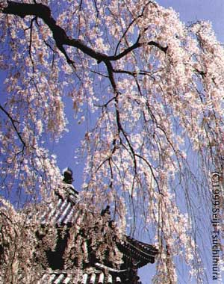
The aboriginals who have occupied the Australian continent for at least 50,000 years developed a deep understanding of the interrelationships between the environment and its influence on fauna and flora. Aboriginal calendars recognize between 5 and 10 seasons, each season defined by the changes in flora and fauna well as the strength of wind, amount of rain and temperature (Keatley in Schwartz, 2003).
dates of cherry flowering in Kyoto
(source: Menzel A, Fabian P (2002) Pflanzen-
und Tierwelt als Boten des Klimawandels. In:
Hauser, W. (Herausgeber für das Deutsche Museum und die Münchener Rückversicherungs - Gesellschaft): Klima. Das Experiment mit dem Planeten Erde. Begleitband und Katalog zur Sonderausstellung des Deutschen Museums vom 7.11.2002 bis 15.6.2003: 218-233.)
Japan has the oldest existing (and still on-going) phenological monitoring record. The flowering of cherry tree has been observed and recorded for about 1300 years (Menzel and Dose, 2005).
A very old European time series of phenological observations is the bud burst of horse-chestnut in Geneva, dating back to 1808. A clear trend towards earlier appearance (0.24 days per year) was detected becoming more pronounced since the beginning of the 20th century. This coincides with the growth and industrial development of Geneva (Defila and Clot, 2001). The climatological and phenological records of the Marsham family in Norwich, England, are another example of a very old European data series, as is the newly published series of cherry flowering in Switzerland which dates back to 1721, and the grape harvest dates from France which go back to the Middle Ages.
Carolus Linnaeus is looked upon as the father of modern phenological networks. The first known phenological network was installed by him in Sweden in the middle of the 18th century. In his work Philosophia Botanica he outlined methods for compiling annual plant calendars of leaf opening, flowering, fruiting and leaf fall, together with climatological observations “so as to show how areas differ (Schnelle, 1955).
Many of the “modern” phenological networks started in the middle of the 19th century (e.g. in the Austrian Hungarian monarchy organized by the NMS, in the US by the Smithsonian Institute or by the Royal Society of Canada). At the same time guidelines for phenological animal and plant observations were published, for example, by Fritsch in the 2nd yearbook of the newly founded K.K. Centralanstalt für Meteorologie und Erdmagnetismus, now the NMS of Austria.
In the early 1960s the International Phenological Gardens were founded by Volkert and Schnelle. The idea was to plant clones of different trees and bushes throughout Europe to study their phenological development and to remove any influence of different genetic material (Chmielewski, 1996). At about the same time, networks observing common and cloned lilacs were established in the USA by the U.S. Department of Agriculture (Schwartz & Beaubien in Schwartz, 2003).
In 1993 the Phenological Study Group of the International Society of Biometeorology (ISB) started a new initiative called GPM (Global Phenological Monitoring) whose main objectives are to form a global phenological backbone with a “standard observation program”, to link 'local' phenological networks and to encourage establishment and expansion of phenological networks throughout the world (Bruns et al. in Schwartz, 2003).
The European Phenology Network has been established as platform for phenologists for data exchange, information and network activities (http://www.dow.wau.nl/msa/epn/). The GLOBE Program (Global Learning and Observations to Benefit the Environment, www.globe.gov) founded in 1998, recognized the value of phenological observations in education and encourages students to take scientifically valid measurements in the fields of atmosphere, hydrology, soils, and land cover/phenology combining scientific research with education. In Australia the Macquarie University developed a website which hopefully may serve as nucleus for a network to gather and collate flowering and fruiting observations from observers around Australia (Rice et al, 2001, http://www.bio.mq.edu.au/ecology/BioWatch ). Nevertheless one needs to acknowledge that little in the way of phenological networks are available in some countries, particularly in the Southern Hemisphere.

Applications of phenological observations
Phenological phases (events) reflect, along with other environmental conditions and genetic factors, the characteristics of the climate. Consequently, long series of phenological observations may be used to detect climate variability and/or climate change. The significant response of life cycle events to global changes have caused a strong increase in interest in phenological processes as an indicator for climate change impacts. However, the actual timing of phenological events is also of importance for other issues in education, agriculture, human health, tourism and recreation, bio-diversity and ecology.
The following table gives more details and selected examples for phenological applications:

Agriculture | Providing phenological data as input for crop models, and for the timing of management activities
Biodiversity / Ecology | Assessing the impacts of extreme events, species interaction, migration of plant/animal-communities to new zones (e.g. to higher altitude or latitude), mismatch of timing, e.g. in food chains or mismatch of climate and species
Natural Resource Management | Timing of management activities, resource management under climate change (e.g. locating new reserves, linking of reserves)
Education | Involving school children and the public in scientific research by a very cheap and easy accessible means (plants and animals can be observed almost everywhere without any tool apart from keen interest, some knowledge on plant/animal-identification and some basic rules), thus bringing people closer to nature.
Gardening | Giving information to the public on planning activities like pest control
Human Health | Providing pollen information for sensitive groups, assessing the impact of climate change on vector borne (e.g. ticks, mosquitoes) diseases
Increasing environmental interest | Informing the public on environmental issues like climate change and its effects on vegetation and animals
Tourism, Recreation & Sports | Giving information on phenomena or events that potentially can interest people (e.g., in Austria, bike-tours on cherry-flowering or apricot-flowering are organized, bird watch-tours)
adapted from European Phenology Network

2. Guide to observations
In the following only plant phenology is addressed. Plants have a stationary nature, and can be planted in the location of interest as it is in the case of the international phenological gardens or the global monitoring program.

Principles for observations
Phenological observations do not require costly equipment, as the “instrument” for monitoring the environmental conditions is the plant itself. Indispensable for the observer are the observation form, observation guidelines and binoculars for large trees.
Remarkable stages of plant-growth whose start dates can be determined to a specific day are observed; it is not enough to make records like “in the first days of April”.
The most important precondition to get homogenous comparable data is an exact definition of the phases. Further, observations of the different phases of perennial plants i.e. plants that have a lifetime of more than one year as e.g. native or forest trees, shrubs or fruit trees are carried out on one individual plant. Extreme development that is very early or very late in comparison to other individuals is often associated with the site. Attention should therefore be paid to making sure that the location of the plant to be observed is representative of the observation area. The observer should carry out the observations on the same plant for as many years as possible. Herbaceous plants are generally observed year after year at the same site, e.g. meadow foxtail is often seen in the same meadow and mugwort along the same farm track. This means that the phenological phase in question should have occurred in several plants at this site. Observations of crops are usually carried out at the first cultivated field and all phenological phases during the course of a year reported for this field. It may be important to record additional information for plants that are managed. As for example, the timing of some phenological events may be influenced by changes in varieties of crop species or by watering regimes particularly in regions where rainfall variability is an issue (see metadata).
The frequency of observation depends on growth stage and on the weather. Thus, for example, in spring in the mid- and high- latitudes it may be necessary to make daily observations while during summer and fall (autumn) bi-weekly visits are usually sufficient.
And last, but not least, it can be more valuable to have less, but more exact data, from a limited number of plants than for to have a very extensive program which implies much work and is more likely to be stopped after only a few years of observation.

Which plants
The selection of plants to be observed depends on the aim of the phenological network (for agricultural use, human health – pollen warning, climate change monitoring, education, information of the public, biodiversity, etc.) and on the vegetation zone (mainly related to climate). It is therefore impossible to find plants which can be observed in all climatic regions of the globe and are suitable for all purposes.
In 1993 the Phenological Study Group of the International Society of Biometeorology (ISB) started a new initiative called GPM (Global Phenological Monitoring) whose main objectives, among others, are to form a global phenological backbone with a “standard program” and “flowering phase program”, to link 'local' phenological networks and to encourage the establishment and expansion of phenological networks throughout the world. For the GPM observation program plants where chosen which meet certain criteria, such as easily recognizable phases, sensitivity to air temperature and broad geographic distribution, and the phases should ideally cover the whole growing season. Therefore mainly Northern Hemisphere fruit trees, some park bushes and spring flowers were selected for the program. So some of the species may not grow well in all countries and it may also not be possible to import foreign plants to some countries due to legal restrictions.
In Europe many NMHSs run a phenological network. Seven of these monitoring programs and five other networks run by different organizations were compared. As a result a European backbone program was introduced containing species and phenophases which are at least similar in 60% of these networks (Bruns and Vliet, 2003).
As mentioned above the selection of plants depends on the purpose of the network and on the vegetation zone. But it is strongly advised to include at least some plants of the GPM and/or European backbone program in order to facilitate international network linkages.
Obeying the following basic rules when establishing a generic nationwide network with volunteer observers and a limited botanic knowledge is recommended:
- The plants should be well known and thus easily identified/recognized.
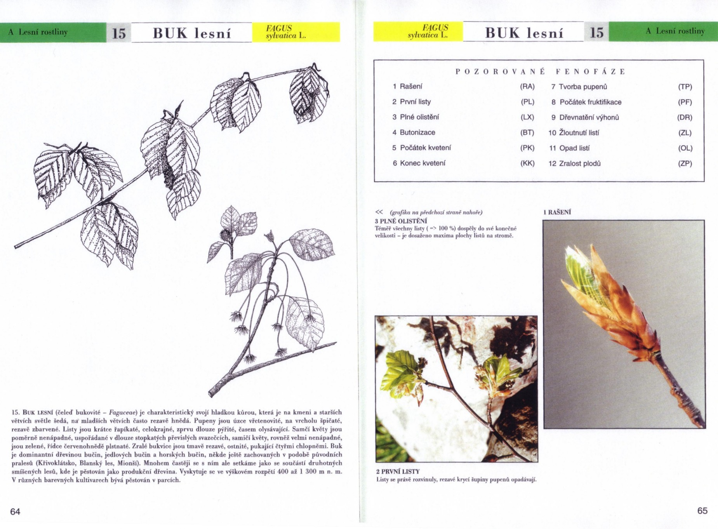
- They should have a broad distribution in the region and in the network should be some plants the phases of which should span the whole vegetation cycle of one year e.g. leaf unfolding, may shoot, flowering, fruit ripening, autumn/fall coloration and leaf fall

Which phases
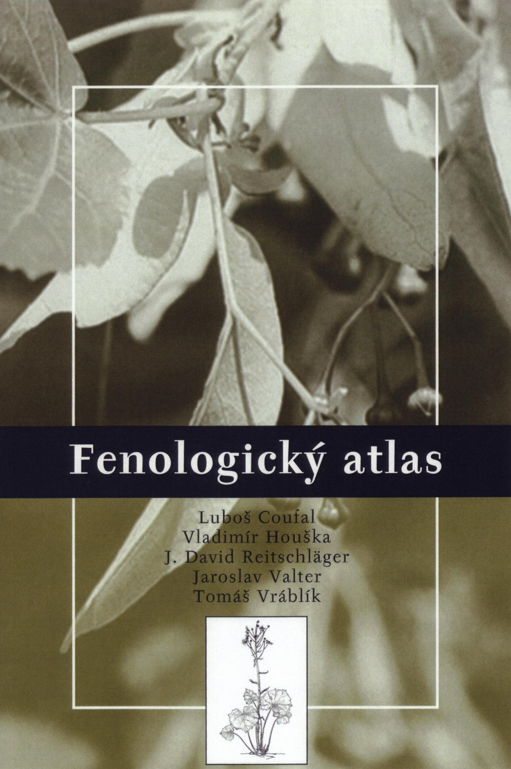
In order to gain comparable phenological data it is necessary to define exactly the phases which are to be observed. The use of the so called extended BBCH scale (Growth stages of plants, BBCH Monograph, 1997) is recommended, based on Zadok et al. (1974) cereal code is a system for a uniform coding of phenological similar growth stages of all mono- and dicotyledonous plant species. It is a general scale so one can also apply it to those plants for which no special scale is available. For the description of the main (longer-lasting) phenological development stages, called principal growth stages, clear and easily recognized external morphological characteristics are used. The secondary growth stages define a short step of development.
Cover and page of the Czech phenological guidelines: Fenologicky atlas, CHMU 2004
The principal growth stages do not need to proceed in the ascending order of the table but can proceed in parallel, for example, flowering stage BBCH6 can occur before leaf development BBCH1 as it does in some fruit trees or, owing to the very different plant species, certain stages may even be omitted.
The secondary growth stages define exact points of time or steps in the plant development. They are also coded with the digits 0 to 9. The numbers 0 to 8 correspond to the respective ordinal numbers or percentage values, 0 defines the beginning, and 9 depicts the end of the principal growth stage (e.g. BBCH60 is the beginning of flowering, BBCH69 the end of flowering). The combination of the numbers of the principal growth stage and the secondary stage results in a two digit code.

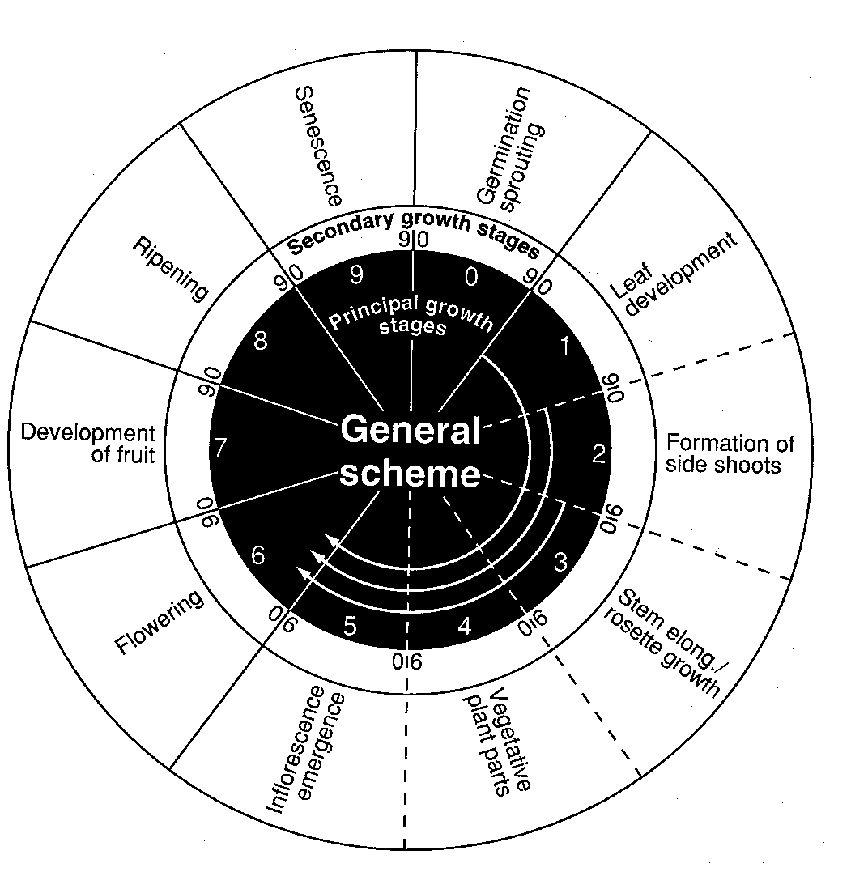
  Principal Growth Stages | Description
  0 | Germination / sprouting / bud development
  1 | Leaf development (main shoot)
  2 | Formation of side shoots / tillering
  3 | Stem elongation or rosette growth / shoot development (maninshoot)
  4 | Development of harvestable vegetative plant parts or vegetatively propagated organs / booting (main shoot)
  5 | Inflorescence emergence (main shoot) / Heading
  6 | Flowering (main shoot)
  7 | Development of fruit
  8 | Ripening or maturity of fruit and seed
  9 | Senescence beginning of dormancy
Principal and secondary growth stages of the BBCH code (source Growth stags of plants, Meier, 1997)

In general it is easier to observe the beginning of one phase, i.e. the secondary growth stages 0 or 1. Therefore, many NMS have chosen this growth stages for many of their observations, especially for phases at the beginning of the growing season. 50% or BBCHx5 is also often used. e.g. BBCH95 (9 being the principal growth stage for senescence, the beginning of dormancy, and the secondary growth stage 5 stands for 50% of the leaves have fallen).

Where
The site of the plant to be observed should be typical for the observation area. Avoid sites which are known to have climatic extremes, or where deviations from characteristic conditions can be expected due to their topography (e.g., southern slopes speed up the plant development in early spring, but on the other hand frost hollows hamper the growth).
The area to be observed is generally determined by the observer. It is rare for all plants/agricultural crops of the program to exist in a small space but an area within a 1.5 – 2.0km radius of the observer’s base (home or workplace) is usually sufficient. Longer distances can be covered, whereby the limit should be around 5km from the base point.
The “mean” geographical observation site and a “reference height“ to which the data refer must be defined for each observation area. This can be done with the help of the observer using an exact map or other means (e.g. GPS) to determine the geographical coordinates and height above sea level. The observation locations should not deviate by more than 50 m above or below this reference height.

When, how often
The frequency of observations depends on the season and plant variety. In temperate zones during the main vegetation period, when temperatures are favorable, the plants may develop at a tremendous speed making it necessary to carry out daily observations in order to obtain the exact date of a defined phase; time spans like mid- May are not sufficiently specific. For determining slower processes (such as fruit ripening) two to three visits per week are usually adequate.
Light and visibility (especially fog, low sun elevation, and the general brightness) exert an influence on the sensitivity for colors of the human eye. Therefore uniform conditions are desirable. For example, the color of leaves is best determined when the sun is high and behind the observer (best time for this is early afternoon). This time of the day also helps to eliminate the possibility that phases might have been “missed“ during previous observations (blossoms of different species often do not open until late morning). And to emphasize again, the exact day when reaching a certain phase is to be recorded.
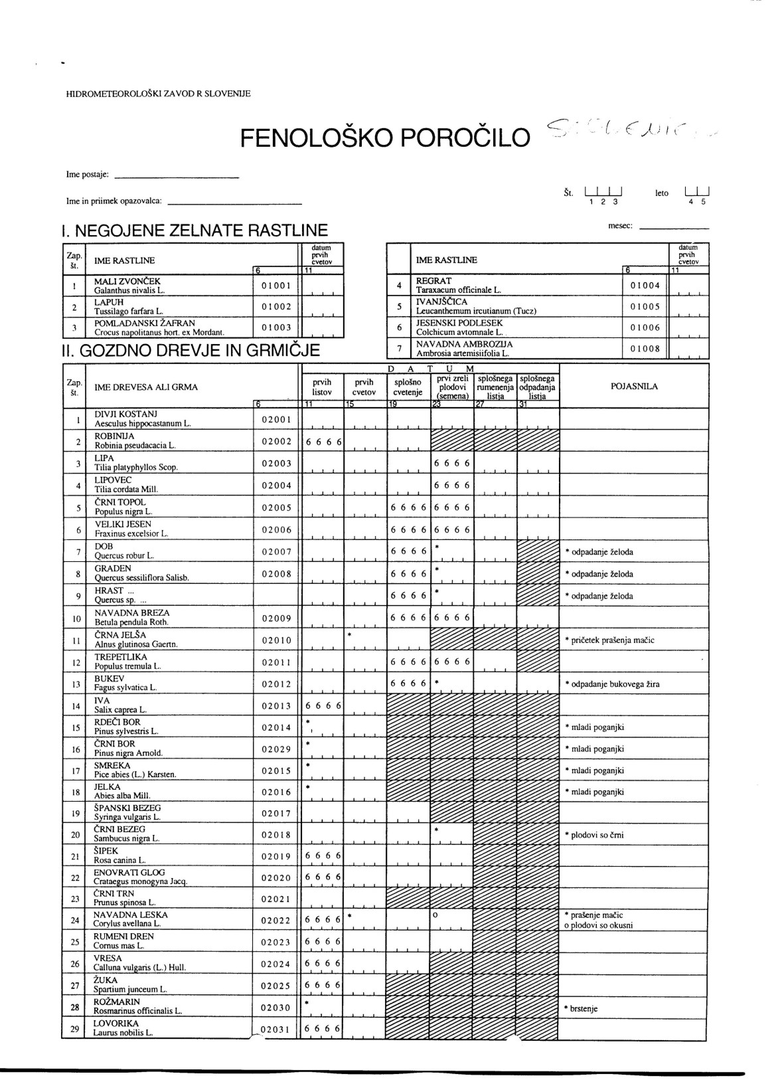
Observation sheet, observation manual
The observation sheet contains all plants and species that are part of the phenological program. Here the plants/phases can be arranged chronologically according to their appearance in the course of the year or all phases from one plant are grouped in one line following their natural development. If online data delivery via the internet exists, it is also of use for the observers to have a list with all plants and species.
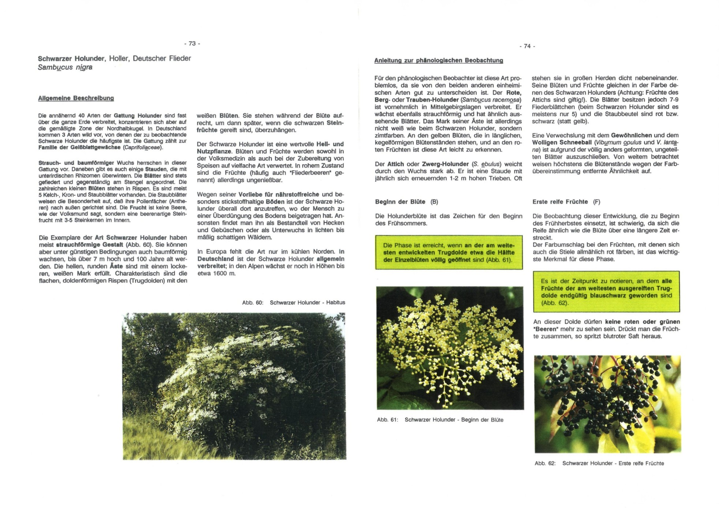
The purpose of the network determines the timing of the data transfer to the centre. For agro meteorological utilization or for pollen monitoring it is necessary to transmit the data as soon as a phase has occurred. In the case of a generic network it is sufficient that the observations sheets are mailed to the organization once or twice a year.
Observations sheet of Hidrometeoroloki zavod Republike Slovenije
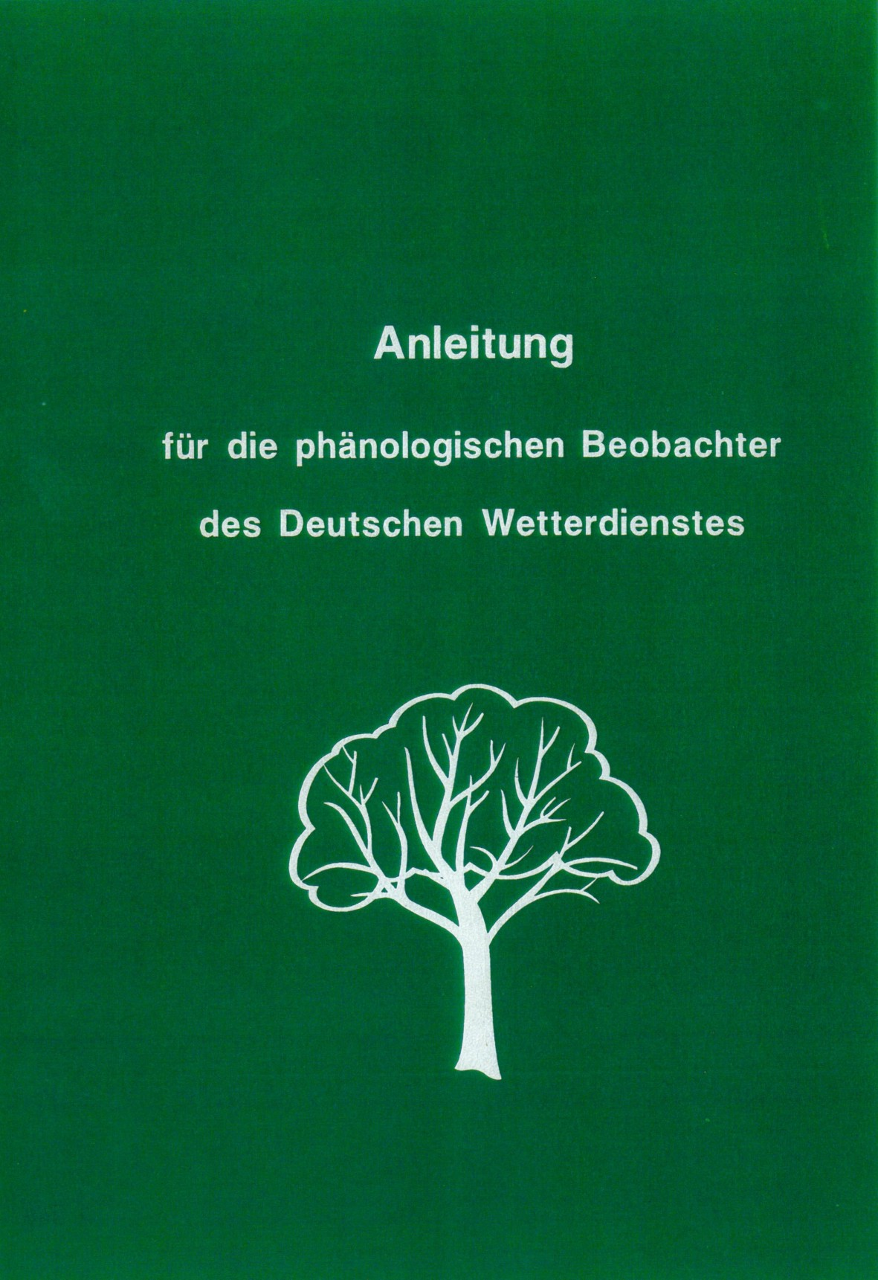
The observation manual should give clear rules for the observers. Pictures and graphs help to illustrate the phenological program. As it is unavoidable that some changes occur in the course of time a folder or something similar, with exchangeable pages, is used by the German and Austrian NMS.
Cover and page of „Anleitung für den phänologischen Beobachter des Deutschen Wetterdienstes“

3. Data Documentation – Metadata
Metadata should reflect how, where, when and by whom the information was collected. As it is with climate data, data documentation in phenology is of paramount importance. The metadata includes the administrative data as name, address of the observer, data inventories (what data are stored where), station description (local environment, exposition, soil type, etc.), histories and data set documentation.
The metadata inform the user which phenological data (plants, varieties, phases) are available, which observing rules are applied, and where the stations are located; they help to detect breaks in time series and thus make the observations comparable with each other.
The third of the ten GCOS Climate monitoring principles emphasizes the importance and necessity of metadata: “The details and history of local conditions, instruments, operating procedures, data processing algorithms and other factors pertinent to interpreting data (i.e. metadata) should be documented and treated with the same care as the data themselves” (http://gosic.org/GCOS/GCOS_climate_monitoring_principles.htm).

4. Data management
Observations are fundamental to all empirical scientific research and analysis. But before you are able to evaluate them, they must be collected, digitized, quality controlled, archived and made accessible for the research community.
As many of the ultimate uses for data cannot be foreseen (e.g. the global change issue) when the data acquisition programs are planned, it is critically important that phenological data and information are managed properly in a systematic and comprehensive manner. For phenological data, management systems are needed to control and handle data from the traditional observations as well as, in some cases, NDVI-data (Normalized Difference Vegetation Index) from satellites.
The design of the data, flagging of data and metadata tables depends on your database management system. Adding the phenological data to the existing database of a NMHS is the best solution as no new or stand alone software or hardware is needed. If it is necessary to build stand alone database equipment, a standard PC system with enlarged memory and additional data storage devices are adequate.
Data can come to the processing center by mail, email, mobile phone or via the internet. Paper data must be controlled, and contain a station identification and a correct date of observation. A book of arrivals should operate the incomings and if observations are missing, a recall should be made. The data quality control guarantees a high standard by applying certain checking routines on the data. The data control software must guarantee that all data passes this process and the results must be marked in the flags. Handbooks and instructions must be written and obeyed. From time to time an internal and an external audit must take place to guarantee the quality of the quality control process.
The organization of the digital database and paper archive must be done in such a way, that retrieval of data and metadata both in digital format and on paper can be easily accomplished. The whole facility up from paper archive to digital database, their copies, and backups must be protected and sheltered against fire, water, flood, humidity and temperature extremes, insects, pest, etc.
The data management task for a phenological network is very similar to the task for running a climate network. So if you want to have a deeper and more comprehensive insight, please have a look on the “Guidelines on Climate data Management, WMO,2005”.

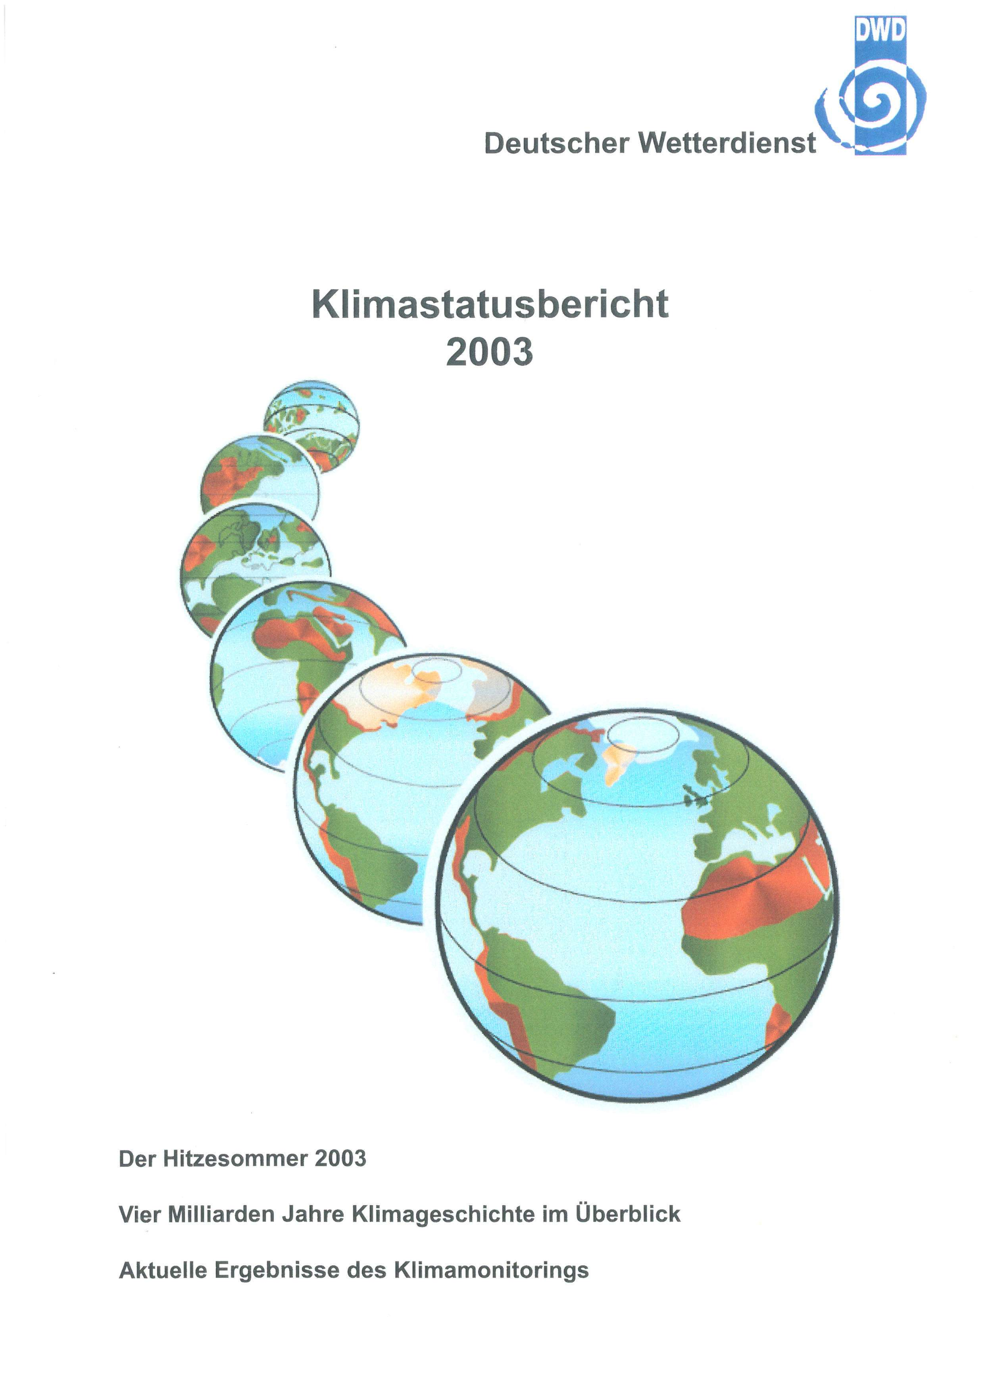
5. Going public – publications, services and products
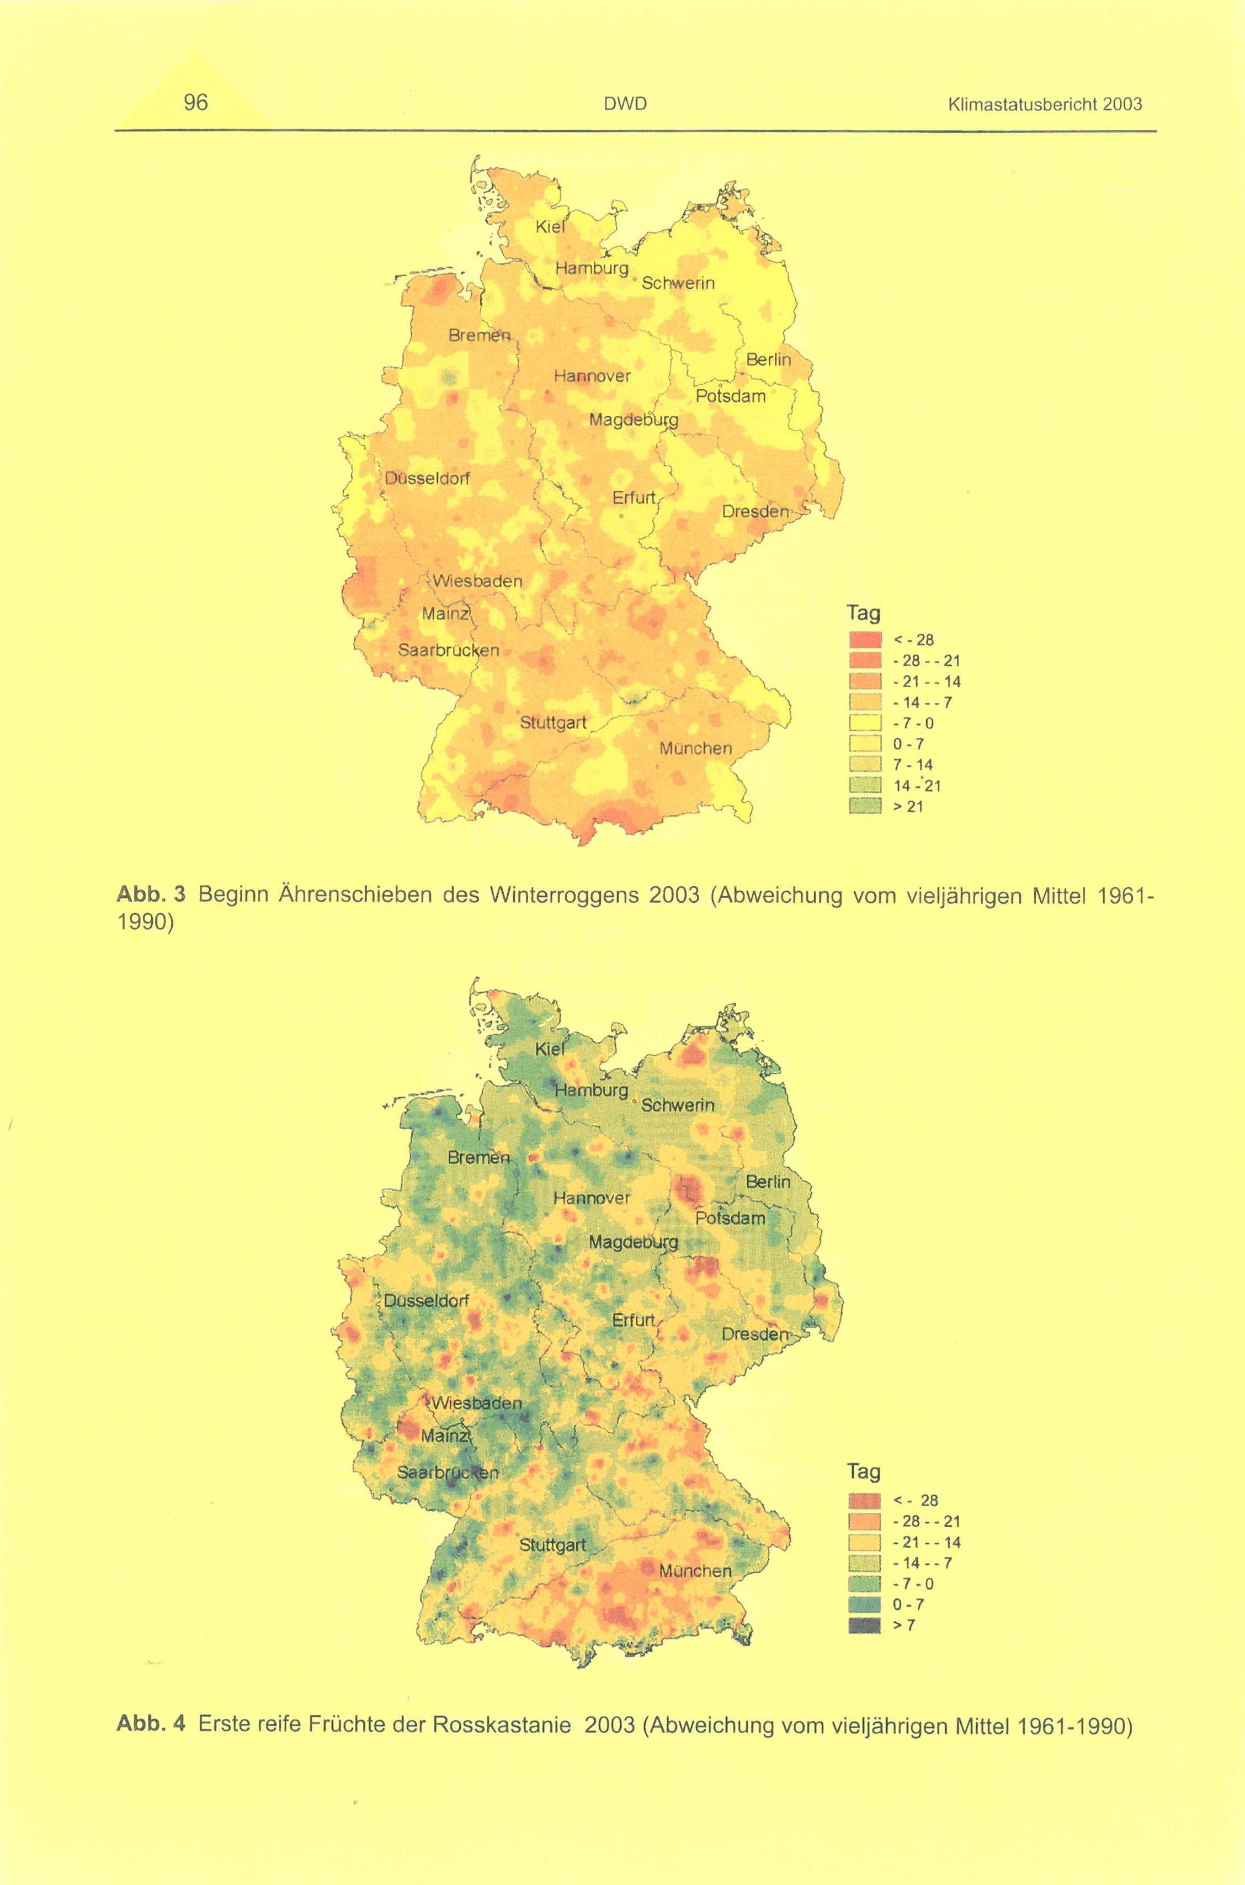
Since the advent of interest in climate and climate impacts by not only climate researchers but by the general public, and with the availability of electronic data processing and publishing/and graphic software, many NMHSs have started to edit professional-looking and attractive phenological reviews with graphs and maps along with tables.
Periodical and occasional data-publications meet the more general need for data, customer tailored services and products help to strengthen the relationship between the NMHS and their clients.
Cover and page (phenological maps) of „Klimastatusbericht 2003“ of Deutscher Wetterdienst
There is a growing interest in phenology, especially at the beginning of the growing season. Putting, on the NMHS-web page, phenological information of actual phenological events compared with the long-term average can be very attractive and raise the awareness for the environment in general, and especially weather and climate impacts (e.g http://zacost.zamg.ac.at/phaeno_portal/).
Good relationship with the media is essential. The media can help focus the interest of, not only the general public, but also of politicians and decision makers to climate change and climate change impacts and as a consequence help the NHMSs to raise their perceived relevance and importance in climate change issues.
Regular and occasional press releases issued on certain specific items are essential in creating a good relationship between the media and NMHSs. Keeping personal contacts and having time and an “open ear” for the needs of journalists is necessary.

6. Acknowledgements
This work has benefited enormously from collaboration with Mark D. Schwartz, Tim Sparks and from anonymous reviewers. It was supported by COST, action 725.

7. References
Ahas, R.: Long-term phyto-, ornitho- and ichtyophenological time-series analyses in Estonia.Int. J. Biometeorology 42, 119-123, 1999
Bruns, E., Vliet v. A.J.H.: Standardisation of phenological monitoring in Europe. 79pp, Wageningen University and Deutscher Wetterdienst, 2003
Chen,X. Li, H. Hu, B. Yu, R., 2007: Surface and satellite based identification of phenological growing season within the temperate climate of eastern China (in German). promet, Jahrgang 33, Heft ½, 46-51.
Chmielewski, F.M: The International Phenological Gardens across Europe. Present state and perspectives. Phenol. Seasonality 1, 19-23, 1996
Defila, C., Clot, B.: Phytophenological trends in Switzerland, Int. J. Biometeorology, 45, 203-207, 2001
Defila, C: Pflanzenphänologischer Kalender ausgewählter Stationen in der Schweiz. Klimatologie der Schweiz, Heft 30/L,233pp, Hrg. Schweizerische Meteorologische Anstalt, 1992
Dunn, P.O., Winkler E.W.: Climate change has affected the breeding date of tree swallows throughout North America. Proceedings of the Royal Society of London, Series B 266, 2487-2490, 1999
European Environment Agency: Impacts of Europe’s changing climate, An indicator-based assessment. 100pp, Luxembourg, 2004
Keatley, M.: Influences on the flowering phenology of three Australian Eucalyptus. Proceedings of ICB-ICUC’99, Sydney, WMO/TD No 1026, Geneva, 2000
Koch E., Scheifinger H.: Phenology as a biological indicator for a warming Europe. World Resource Review Vol 16, No 2, 2004
Koch E.: Phenology in Austria: Phenological Mapping, Long Term Trends. Proceedings at ICB-ICUC’99, Sydney, WMO/TD No 1026, Geneva 2000
Lieth, H., editor: Phenology and Seasonality Modeling, Springer Verlag, New York, 444pp, 1974
Meier, U. (ed.): Growth stages of Mono- and Dicotyledonus Plants. BBCH Monograph, Blackwell Wissenschafts-Verlag Berlin Wien, 622pp, 1997
Menzel A, Sparks T, Estrella N, Koch E, Aasa A, Ahas R, Alm-Kübler K, Bissolli P, Braslavská O, Briede A, Chmielewski FM, Crepinsek Z, Curnel Y, Dahl Å, Defila C, Donnelly A, Filella Y, Jatczak K, Måge F, Mestre A, Nordli Ø, Peñuelas J, Pirinen P, Remišová V, Scheifinger H, Striz M, Susnik A, van Vliet AJH, Wielgolaski FE, Zach S, Zust A: European phenological response to climate change matches the warming pattern. Global Change Biology ,12, 1969-1976, 2006
Menzel, A, Dose V.: Analysis of long-term time-series of beginning of flowering by Bayesian function estimation. Meteorologische Zeitschrift, 14 (3), 429-434, 2005
Morellato, L.P.C., Haddad, F.B.: The Brazilian Atlantic Forest. Biotropica special issue Vol. 32, No 4b, 2000
Parmesan, C., Galbraith H.: Observed Impacts of global climate change in the US., 56pp, Pew Center on Global Climate Change, Arlington, VA, 2004
Rice, B., Hughes L., Reed M., Westoby M.: A phenology web-network for Australia. www.uow.edu.au/science/biol/eas/posters/Raice.pdf, Proceedings of the 2001 meeting of ESA at the University of Wollongong, 26-28/9/2001
Sarvas, R., Investigations on the annual cycle of development of forest trees II. Active period. Communicationes Instituti Forestalis Fenniae, 84, 1974
Sarvas, R.: Investigations on the annual cycle of development of forest trees I. Autumn dormancy and winter dormancy. Communicationes Instituti Forestalis Fenniae, 76, 1972
Scheifinger H., Winkler H., Koch E.: Arrival Dates of migrating birds in Central Europe and climate variability. Proceedings of the ICAM 2005, Zadar Croatia, 23-27/5/2005
Schnelle, F.: Pflanzenphänologie, Leipzig, Germany, 299pp,1955
Schwartz M.D. (ed.): Phenology. An integrative environmental science. Dordrecht, The Netherlands, Kluwer Academic press, 564pp, 2003
Sparks, T.H., Menzel, A.: Observed changes in seasons: An overview, Int. J. Climatology, 22, 1715-1725. 2002.
Sparks, T.H.: Phenology and the changing pattern of bird migration in Britain, Int. J. Biometeorology 42, 134-138
Vliet, A.J.H., Braun P., Brügger R., Bruns E., Clevers J.: European Phenology Network. Nature´s Calendar on the move, 64pp, Wageningen University, The Netherlands, 2003
Zadok, J.C., Chang T.T., Konzak C.F: A decimal code for the growth stages of cereals. Weed research 14, 415-421 and Eucarpia Bulletin NO. 7, 49-52, 1974

perennial plants live for more than two years
a plant lacking a woody stem is called herbaceous
monocotyledonous plants (have one cotyledon per seed; there are about 50.000 species of monocotyledonous plants including the grasses (as for instance rye, corn, wheat) and lilies, bananas and orchids). A cotyledon is the first leaf or the first pair of leaves (dicotyledonous plants) developed by the embryo of a seed plant or of some lower plants as e.g. ferns
dicotyledonous plants have two cotyledon per seed; The dicotyledonous plants contain nearly 200.000 species from tiny herbs to great trees

